FOR IMMEDIATE RELEASE
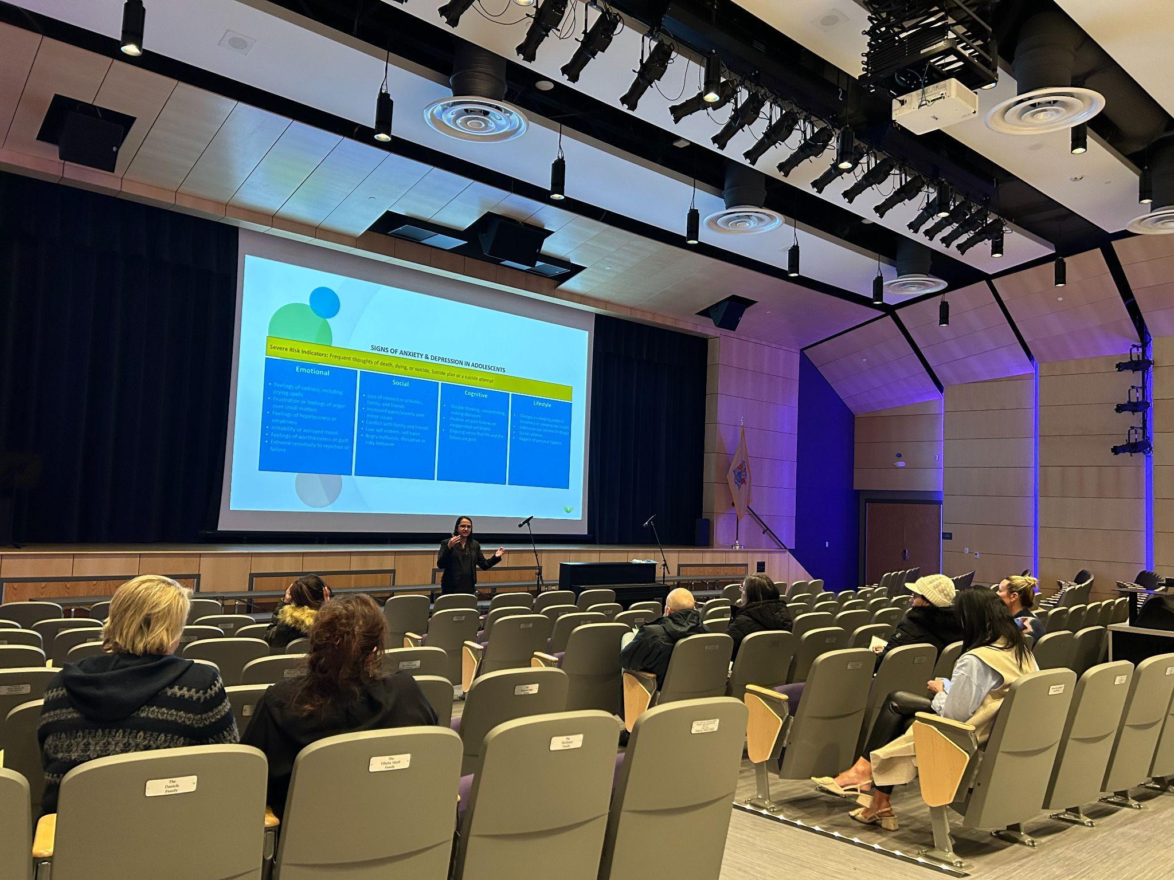
Rumson, NJ- On Thursday, December 14, 2023, the Rumson School District Department of Student Services organized a community conversation with Ajita Shah, LPC, NCC, ACS, PMH-C, the Founder and Program Director at Innerspace Counseling. Dr. Michael Snyder, Director of Student Services for Rumson, highlighted that the event aimed to educate parents and caregivers about the prevalence of school avoidance and anxiety among students. The event provided an opportunity for parents to gain valuable insights into understanding and addressing the challenges their children may face, ensuring a supportive environment for growth and development.

In her role as the Founder and Program Director at Innerspace Counseling, Ajita Shah has emerged as a leading voice in addressing the pervasive issues of school avoidance and anxiety among children. Leveraging her expertise, Shah offered invaluable insights into the profound impact of these challenges on students' overall well-being. She articulated concrete strategies for parents and caregivers to effectively support children grappling with these issues. Shah underscored the critical importance of fostering a safe and nurturing environment where children feel empowered to openly express their emotions and concerns. Furthermore, Shah emphasized the need for a unified and collaborative approach, which involves the active participation of school personnel and mental health professionals, in addressing the underlying causes of school avoidance and anxiety. By advocating for early intervention and proactive communication, Shah highlighted the potential to equip children with the necessary tools to navigate these difficult experiences.

Dr. Snyder provided further insights, emphasizing the need to create a cooperative structure in order to adequately assist children facing these difficulties. He emphasized the importance of transparent and collaborative endeavors involving all parties involved in a child's education so that crucial resources and interventions can be easily obtained. Recognizing the fundamental role of understanding the root causes of school avoidance and anxiety, Dr. Snyder posits that “a nurturing and supportive environment can be cultivated where children feel comprehensively supported and empathetically understood.”

Dr. Snyder reinforced the fact that school avoidance and anxiety are common experiences for many children but it is essential for parents to recognize when these feelings become significant barriers to their child's education and mental health. It is important to take action and seek help when necessary, as ignoring these concerns can lead to long-term academic and emotional consequences for children. By acknowledging and addressing school avoidance and anxiety early on, parents can help their children develop healthy coping strategies and work with community members to create a positive environment for their education.

The event also provided an opportunity for parents and caregivers to ask questions and seek guidance from Ajita Shah, who shared her expertise and experience in the field of mental health counseling. The Rumson School District Department of Student Services is committed to addressing the mental health needs of its students and supporting parents and caregivers in navigating these important issues. Dr. Snyder states, “By providing access to valuable resources and expert guidance, the district aims to create a supportive and informed community that prioritizes the well-being of its students. By learning the signs, understanding the impact, and gaining practical strategies to support their children, parents and caregivers can play a crucial role in nurturing their child's mental well-being and ensuring their academic success.”

